**Chehalem Park and Recreation District Middle School Track and Field**

**2016 Meet Schedule**

Schedule May Change

Check Weekly

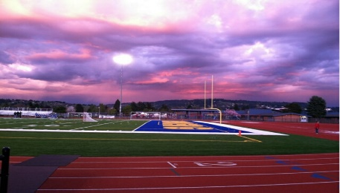

|  |  |  |  |  |  |
| --- | --- | --- | --- | --- | --- |
| **Date** | **Hosting Team** | **Location** | **Time** | **Teams** | **Bus Pick Up Time/Place** |
| **Thursday, March 31** | **La Creole** | **Dallas High School**  **1250 SE Holman Ave, Dallas** | **4:00 pm** | **Duniway, Newberg** | **MV Students: Bus Pick Up at 2:30 pm**  **CV Students: Bus Pick up at 2:30 pm**  **After Meet Drop Off @**  **The Chehalem Aquatic Center (1802 Haworth Ave)** |
| **Wednesday, April 6** | **Newberg** | **Newberg High School**  **2400 Douglas Ave, Newberg** | **4:00 pm** | **Patton, Talmadge** |  |
| **Wednesday, April 13** | **Molalla** | **Heckard Field**  **399 Eckard Street, Molalla** | **4:00 pm** | **North Marion, Newberg, French Prairie** | **MV Students: Pick up at 2:30 pm**  **CV Students: Pick up at 2:30 pm**  **Drop Off After Meet at**  **The Chehalem Aquatic Center (1802 Haworth Ave)** |
| **Wednesday, April 20** | **Newberg** | **Newberg High School**  **2400 Douglas Ave, Newberg** | **4:00 pm** | **North Marion, Yamhill-Carlton, La Creole** |  |
| **Thursday, April 28** | **Patton** | **McMinnville High School**  **615 E. 15th Street, McMinnville** | **4:00 pm** | **Duniway, Yamhill-Carlton, Newberg** | **MV Students: Pick up at 2:30 pm**  **CV Students: Pick up at 2:30 Drop Off After Meet at**  **The Chehalem Aquatic Center (1802 Haworth Ave)pm** |
| **Thursday, May 5** | **French Prairie** | **Woodburn High School**  **1785 N. Front Street, Woodburn** | **4:00 pm** | **Molalla, Newberg, Duniway** | **MV Students: Pick up at 2:30 pm**  **CV Students: Pick up at 2:30 pm Drop Off After Meet at**  **The Chehalem Aquatic Center (1802 Haworth Ave)** |
| **Thursday, May 26** | **Corvallis** | **1400 NW Buchanan Ave,**  **Corvallis** | **4:00 pm** | **Meet of Champions**  **\*Invite Only\*** |  |